# Linear Analysis: Reduction Policy

In order to carry out any large-scale linear analysis, whether of harmonic units or intervallic content, a process of segmentation needs to be established. Given the scale of the corpus study, this must be replicable in a vast array of contexts, and therefore simplicity is likely to be much more successful than a complex multi-part algorithm that tries, and likely fails, to take account of a large range of individual circumstances. Various segmentation approaches can be deployed, depending on the aspect of harmony under consideration: for example, intervals between pairs of notes (so a segmentation of every consecutive pair of notes), or the harmonic content of three consecutive notes (a possible motif). In each case, however, the particular notes under consideration have to be strictly defined: after all, in a contrapuntal texture the intervals between notes in different parts are unlikely to be relevant. Hence, when considering the linear intervals between the two chords presented in Exx. 1 & 2, the result is a semitone, a tone, and a perfect fifth, as in Example 1, rather than calculating three intervals per note, as in Example 2.

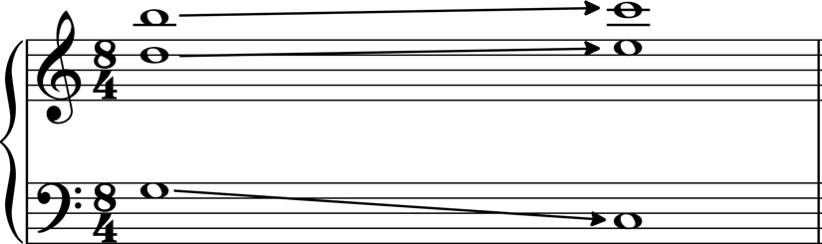

Example 1

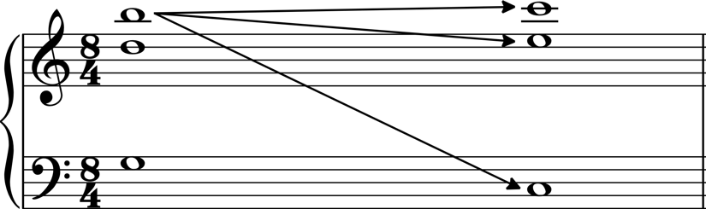

Example 2

The examples presented above are clearly very simple; assessing voice-leading is easy. In a more contrapuntal texture, especially one without conventional functional harmony, the matter is rather more complex. Nonetheless, in order to assess linear tendencies in any work, such a contrapuntal reduction has to be produced, in order to define which notes are related, and so what constitutes a relevant interval or harmonic unit. The clarity of these contrapuntal voices across the 31 works in the corpus varies hugely. In some of the later chamber music, for example, contrapuntal voices are made very clear through a combination of instrumentation, texture, and register; conversely, in piano writing particularly, consistent individual voices can be much harder to establish. The following policy outlines the general approach I have taken in producing such a contrapuntal reduction that is suitable for computational analysis. The fundamental goal is to produce a version of each movement that has some number of individual monophonic parts that, together, give the fully-realised work, and so take account of all individual voices without unnecessary doublings.

The fundamental contention of my approach is that segmentation is most obviously defined by instrumentation; that is, individual voices are restricted to individual instrumental parts, and do not cross. This may seem naïve, particularly compared to some of the larger scores of Webern’s contemporaries (Schoenberg’s Op. 16 immediately comes to mind, as do all of Mahler’s symphonies); nonetheless, with no obvious instructions to the contrary (he eschews *Hauptstimmen* in his notation) it is difficult to consistently assert otherwise, and in an atonal context instrumentation provides such a clear structural guide. Clearly this means that the contrapuntal structure cuts against the serial voices in those movements organised through linear topography; this seems viable given the role of the serial process as a *background* structure rather than a motivic one. Unison doublings in pairs of instruments (e.g. two flute parts playing the same music) have been removed, but octave doublings are retained, as are unison doublings in different instruments, although these are fairly rare. When pairs of instruments play different lines these have been treated as consistently independent voices (e.g. the horns at the opening of Op. 21/i). There is a plausible argument that in some cases the aggregate of two parts, particularly given wide registral leaps, should be understood to produce one composite voice, or indeed two independent voices distinct from the notated parts, however this is such a subjective assertion as to be unfeasible to model comprehensively, depending as it does on the variable performance of individual players and perception of different listeners. I therefore assume that Webern meant to write individual parts as producing meaningful independent contrapuntal lines, a not unfair assertion given his obsession with counterpoint.

For keyboard instruments I have extended this approach, treating each stave as a separate line, unless the result is very obviously monophonic and split staves are simply to facilitate playing. In fact, particularly in the later work, Webern often uses cross-stave beams to indicate contrapuntal groupings, validating this approach. In chordal passages, whether on a keyboard instrument or elsewhere (e.g. string double-stops, guitar chords), if the chords have a consistent number of voices I have presumed that voice-leading follows register (so, the top voice remains top, second-down remains second-down, etc.). If the number of voices changes, I have constructed the extra note as coming from or leading to another note in the other harmony, which has been calculated according to the axiom of minimal movement (so, if a three-note chord becomes a four-note chord, as in Example 3, that new note is deemed to be connected to a note in the previous chord).

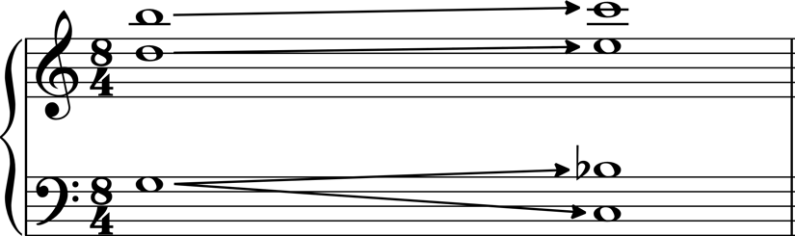

Example 3

The other point of contention regards rests: how long does a rest need to be until the notes either side should be deemed disconnected? This could be debated extensively, for example with regard to registration, what else happens in that rest, and other factors. Nonetheless, in the context of these works it seems unlikely that listeners are expected to mentally prolong a note for any extensive period of time. Thus, if the rest is longer than half the duration of the bar, I view the notes on either side as disconnected.